CHESTNUT LANE SCHOOL
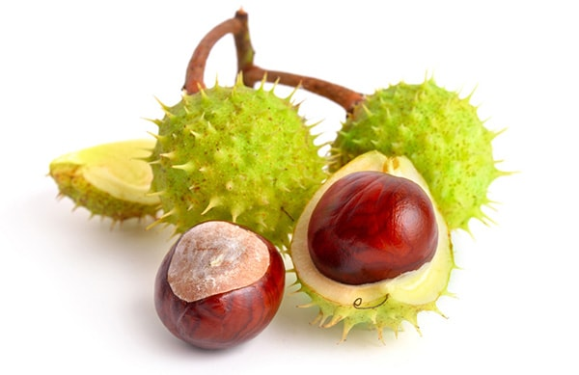
LITTLE CHESTNUTS NURSERY
APPLICATION FORM

Please be aware that being offered a place in the Nursery
DOES NOT guarantee your child a place at Chestnut Lane Infant School (Reception)

(There will be additional forms from the Education Department to be completed at a later date)

Date of Application: Click here to enter text.

School Catchment Area: Inside* ☐ Outside* ☐ (* Please tick)

Surname: Click here to enter text. Date of Birth: Click here to enter text.

Forenames: Click here to enter text.

Address: Click here to enter text.

Postcode: Click here to enter text. Telephone No.: Click here to enter text.

Email Address: Click here to enter text.

Ethnic Origin: Click here to enter text. Gender: Female* ☐ Male* ☐ (* Please tick)

Mother’s / Guardian’s name: Click here to enter text. Mobile Telephone No.: Click here to enter text.

Father’s / Guardian’s name: Click here to enter text. Mobile Telephone No.: Click here to enter text.

Nursery School Attended: Click here to enter text.

Medical information: Click here to enter text.

Special Educational Needs / Additional information: Click here to enter text.

Other Children in Family: (oldest first)

Name: Click here to enter text. D.O.B.: Click here to enter text.

School Attended: Click here to enter text.

Name: Click here to enter text. D.O.B.: Click here to enter text.

School Attended: Click here to enter text.

Signed: Click here to enter text. Date: Click here to enter text.

FOR OFFICE USE:

Acknowledgement of application: Nur.Off.Let: R5.Off.Let:

